jefa-steering

Innovative JEFA steering traveller

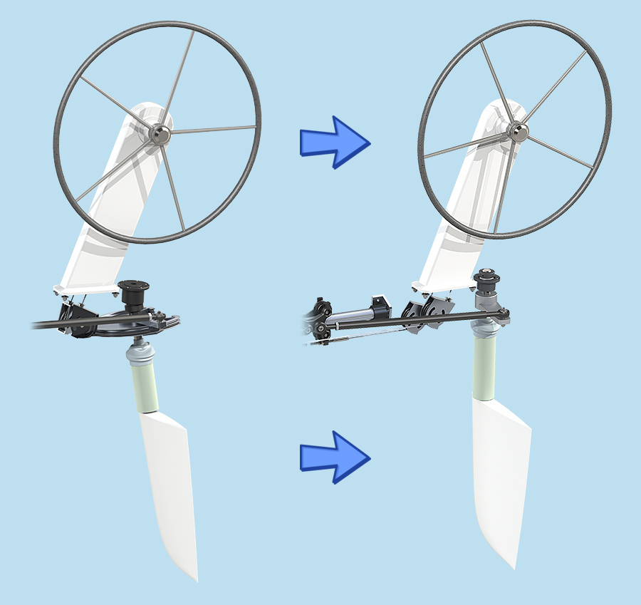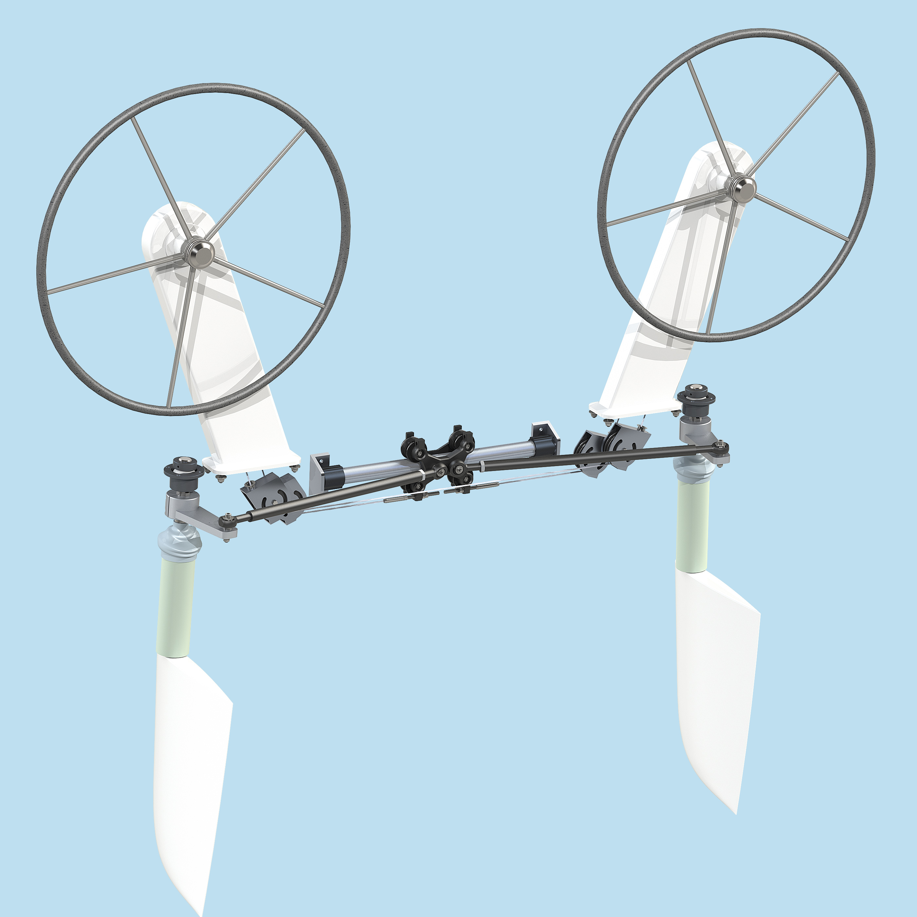Jefa Steering has developed a new innovative traveller system for modern twin wheel, twin rudder sailing yachts. Traditionally cable systems required a wire quadrant and twin rudder boats even required twin quadrants. These (in average 50 cm diameter) quadrants take up a lot of space and due to the slanted rudders required a difficult wire routing to reach them. Experiments have been conducted to use standard deck travellers to transfer the cable movement into rudder movement, but as one can’t get them without play, they distort the rudder feel every time the wheel is rotated. The new Jefa traveller is without this backlash and specially made to attach cables and draglinks. The Jefa traveller is a revolutionary steering solution for twin wheel, twin rudder boats and a huge space saver.

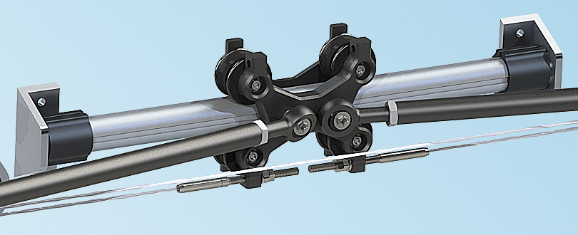The Jefa steering traveller consists of a wagon with 4 rotating special shaped wheels which fit on a tube with tracks. The tracks prevent the traveller from rotating around the tube so it can only move sideways. The traveller wagon has two ø16mm pins fitted to connect draglinks and holes with good accessibility to attach wire terminals from the pedestals. The traveller can be used for most sizes of yachts and the gearing ratio can be changed with the length of the tiller arm on the rudderstock.

What makes the Jefa steering traveller unique and an absolute innovation?

1. The for centuries used bulky steering quadrants can now be replaced by the new compact steering traveller.
2. Revolutionary, innovative traveller system to link twin rudders on twin wheel boats.
3. Huge space saver!
4. Unique system to transfer cable movement into rudder movement.
5. Free of any backlash or play.
6. No loss of any helm feel on the steering wheel.

Jefa Steering ApS  
Agenavej 43  
2670 GREVE  
Denmark  
Tel: +45-46155210  
Fax: +45-46155208  
  
Jefa Sales Office  
The Netherlands  
Tel: +31 475 537760  
Fax: +31 475 537759  
E-mail: [sales@jefa.com](mailto:sales@jefa.com)

1. Special usage for cross-bow connections in catamarans.
2. Maintenance free due to the use of anodized marine grade aluminium.
3. Large weight save compared to quadrant solutions.
4. Price saving compared to the current quadrant solutions.
5. To safe space and prevent damage, some production boats are delivered without the rudders mounted. The Jefa Steering traveller allows the full steering system to be installed and just the draglinks to be mounted when the rudders are mounted in the hull.

A YouTube movie on the functioning is available. Please follow this QR code

Press pictures are available on our public FTP server.  
Please follow this link: **ftp://ftp.jefa.com/steering/press/traveller**